
Supplying the Rudimentary Resources of Scouting of all Sections March 2002

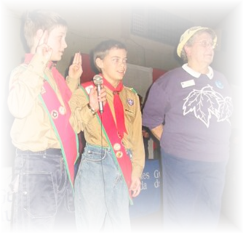
The Scouting Scope
Welcome to the first edition of the Scouting’s Scope. The aim of this resource-based newsletter is to give Scouters of every section a more focused look at some of Scoutings more fun and challenging tasks that Leaders and program builders face in the 21st century. All of the information contained in this resource is from the amalgamated file of Jeff Melvin (chief-editor and contributor). I encourage you to follow the PPP rule with this resource (Print, Promote, and Pass-along).

You will find that the information in this newsletter will have locally “Field Tested” ideas on GAMES, SONGS, PROGRAM ACTIVITIES, STORIES, MEETING PRAYERS, GROUP CHALLENGE, AND SCOUTING QUOTES are prepared for use in your programs. If improper credits are given to a contribution, then please feel free to contact me at scouting@canada.com. Best of luck with your planning on the adventure trail.

Program Activities: Feature article
PROGRAMING? IT’S NOT ROCKET SCIENCE
Planning is as essential to success in Scouting as it is in every other area of life. Planning gives purpose and direction to your efforts. Planning ensure vitality and progress. Planning helps in program development leading to adequate programming and therefore to good Scouting. The basic appeal of Scouting is proved. Imaginative, intelligent planning, brings it to the youth. Your general purpose in program planning must be to make your programs so full of fun, adventure, romance and interest, that member will remain and others will want to belong. How attracting is your plan?

Think of the following to set yourself on line…
✓Action is better than inaction
✓Participation is better than looking on
✓Outdoors is more fun than indoors
✓Unusual is more exciting than the usual
✓Surprise is more interesting than the expected
✓Mysterious is more appealing than the obvious

Plan Your Work-Work Your Plan
Planning- use sixer’s or patrol councils, assistants and instructors
✓Plan three months in outline
✓Plan one month in detail
✓Put the plan on paper
✓Have a job for all; let them know; verify the job
✓Complete change of tasks every so often
✓Fun is important

Get Sixty Minutes Out of Every Hour
➔ See that the opening and closing ceremonies don’t drag (5-10 minutes each)
➔ Start right on time, don’t wait for no one! (ie., Opening at 6:30 pm sharp if you meet at 6:30 pm)
➔ Attendance and dues goes to small group Leaders as soon as Youth arrive
➔ Inspection should be short, snappy, and thorough
➔ No lagging between programs items; assistants must keep on their toes
➔ Set a time for the following and then beat the time down..

-How long does it take for the section to get into a circle?
-How long does it take for the section to become quiet?
-How long before the last youth leaves the hall?
-Don’t overplay games, five minutes is long enough

Atmosphere: Distinctive- Unusual- Thrilling
Terminology- Akela, Scouter, Skip, Bubbles, (not sir or madame)
Opening and closing- Grand Howl, Parade Circle, or Building the Dams
Stories- Crafts- Excitement

Discipline: Happy, But Firm and Just
✓Based decisions on the promise and applies at all times
✓Speak in a low, firm voice
✓Keep the program moving
✓Uniform and dues help provide a sense of belonging
✓Waiting list develops keenness
✓Atmosphere- unusual, clean, punctual
✓Call of “Pack” or “Troop” means freeze
✓Games well controlled, rules fully explained

Instruction- Important Part of Program- 10-15 Minutes
Progress for all- requires short and long-term planning
Chart- Use a badge chart to show progression (create competition)
Use games, stunts, and quizzes to teach and pass requirements
National Anthem/Song at the end of most meetings
Clothes folded in corners, not jumbled on a stage or floor
Encourage members to call when absent
Lair games- matchstick writing on promise, etc.
Instruction- 5% talk, 10% demonstration, 85% practical work

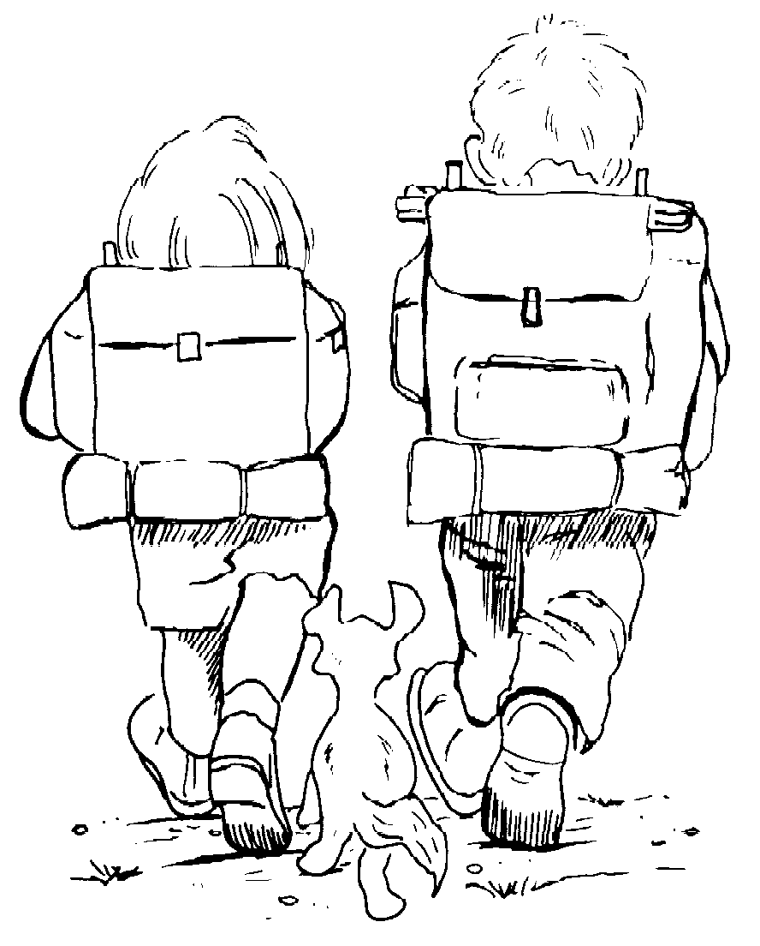
Games- Average 5 minutes
☺Use for passing and reviewing requirements
☺Good discipline start and proper finish
☺Don’t overplay favourite games
☺Points for all Sixes/patrols, ie: last six gains at least one pt
☺Variety of fames is important
Elimination- one type of relay, many ways to play: run, hop, skip, blind-folded, arm in sling, lights out, carry a ball, etc.
☺Let youth suggest and lead games (pre-screen)

Surprise Items- 5 minutes of Every Other Group Meeting
Stunt by leaders/Sixers- a song, a dance, a yell
Presentations- service stars, happy birthday, candy, cake
Observation stunt
Fire drill- demonstration by Scouts- accident- lights out during game
Campfire- songs, games, skits, stories
Acting- good turn, expressions, acting slips, words
Crafts- card for Mother’s Day, present for Father, etc.
Members of other sections can come visit to talk on a particular badge or interest
Visit of Pastor, Chaplain, or Minister-Story on “Duty to God”
Show videos of interesting topics- 15-30 minutes of a video over 4 meetings (1 to 2 per year)

Outdoors- Simple Ideas
☑25%+ of all meetings should be done outdoors- ☑Saturdays- use assistants and parents when you can’t be there…
☑Send out 6 small groups or pairs of youth (with a parent?) to report back by public telephone
☑Good turn- shovel walks
☑Games-Build the biggest snowman, snowball, or snow house, either as youth, group, or section

Games for Your Meeting

Spillikins
Equipment: Medicine bottle; 6 matches per Cub
Formation: Circle
The Pack sits in a circle with the medicine bottle in the center. Each Cub takes it in turns to place a match on top of the bottle, or on the matches already there. If a Cub knocks any off while putting his on, he must take back all those knocked off. The first Cub to get rid of all his matches is the winner.
Note: If the safety matches are given to the Cubs separately from the box, there should be no risk of fire.

Gazelle Stalking
Equipment: 2 blindfolds; 1 chain of bells
Formation: Circle
All players form a circle. Two people are chosen to be the Gazelle and the Stalker. These two people go outside of the circle, where they are blindfolded; they are taken to different sides of the circle.
Those left in the circle are taught two sounds:
1. A clicking sound with the tongue, and
2. A blowing sound (like the howling wind).
The Stalker then tries to catch the Gazelle; to do so he must be careful not to make too much noise. The people in the circle can help the Stalker by giving the clicking sound when he is far away from the Gazelle and by giving the blowing sound when he is getting near.

Chair Basketball
Equipment: 1 chair per person; 1 set of headbands for one team; inflated round balloons; 2 score cards
Formation: Circle-sitting on chairs- alternating teams
Divide the group into two teams. One team wears headbands. Teams sit in the pattern outlined above (chairs are a few feet apart).
The players must remain seated throughout the entire game. The game begins with the placing of a balloon between the two teams. The object of the game is for both teams to attempt to pass the balloon from one team member to another to the end chair, where one member of their team is holding his arms in a circular fashion (similar to a basketball hoop). The team who scores the most hoops in a given period of time wins.

Blind Balloon Volleyball
Equipment: 1 volleyball net; 1 blanket to cover net; 1 referee per balloon
Formation: Teams
Teams of four or more people line up in volleyball fashion on either side of the net. The blanket is placed over the net so that neither team can see the other one.
The referee throws the first balloon in. Each team may hit the balloon as many times as they desire, as long as the balloon doesn't hit the ground. When they are ready, they send the balloon over to the other team.
As soon as one side puts the balloon out of bounds, or touches the ground with the balloon, the other team scores a point. The fun begins when extra balloons are added (up to a maximum of 6) to the game.

Group Challenge
(Meeting Sparkler)-Camp

1. Recycle an object into something useful
2. Identify 5 trees
3. Identify or describe 8 items with a magnifying glass
4. Find nature items beginning from A to Z
5. Construct a simple shelter and spend time in it with a friend
6. Be the first to fall asleep
7. Pick up 15 pieces of garbage and be prepared to talk about man's influence on the environment
8. Create a poem and read it at Scouts Own
9. Make a treasure keeper
10. Don't complain for one day (compulsory for all!)

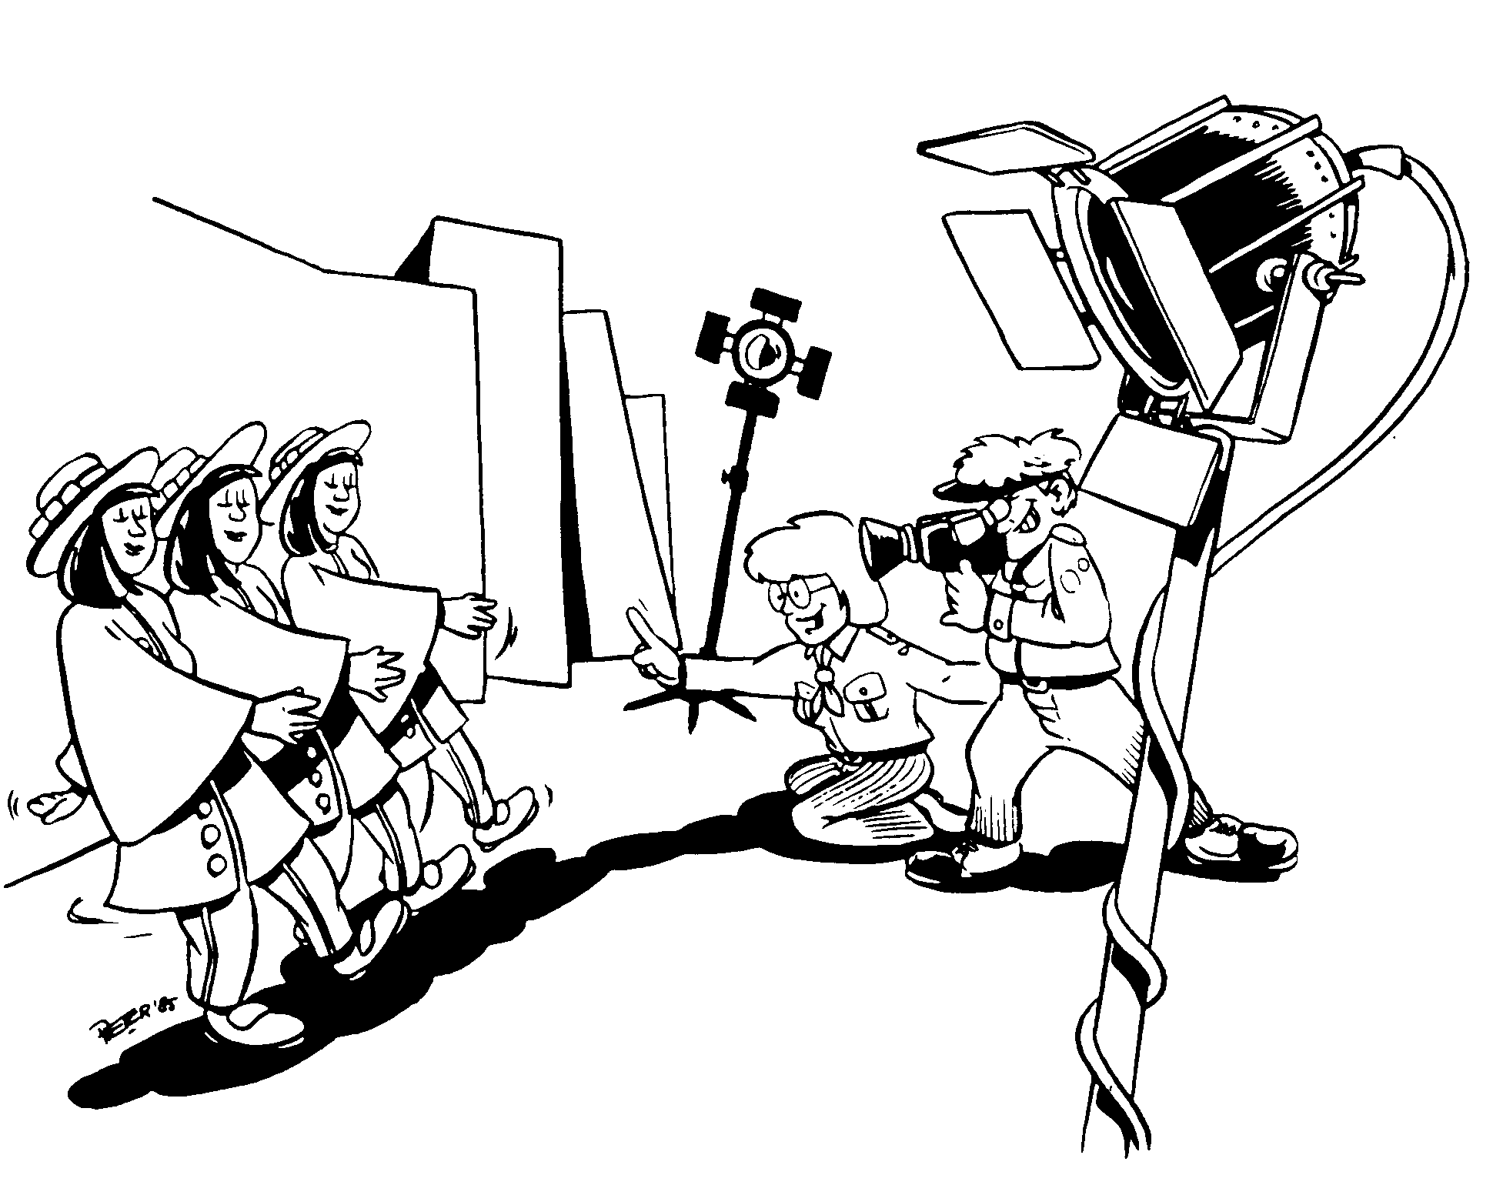
Songs & Yells
Almost Yell: With hands far apart, bring them rapidly together but miss just before meeting each other.
Apollo Yell: Shout: Countdown, 10 - 1 !! BLASTOFF! then with your hand gain orbit and even out. Then say, "BEEP, BEEP, BEEP, BEEP."
Archery Yell: Mimic shooting an arrow, then call out, "Bull's Eye!"
Artillery Yell: Begin slowly with the flats of your palms and increase in speed: then slow down until finally the last time the hands are not
brought together.

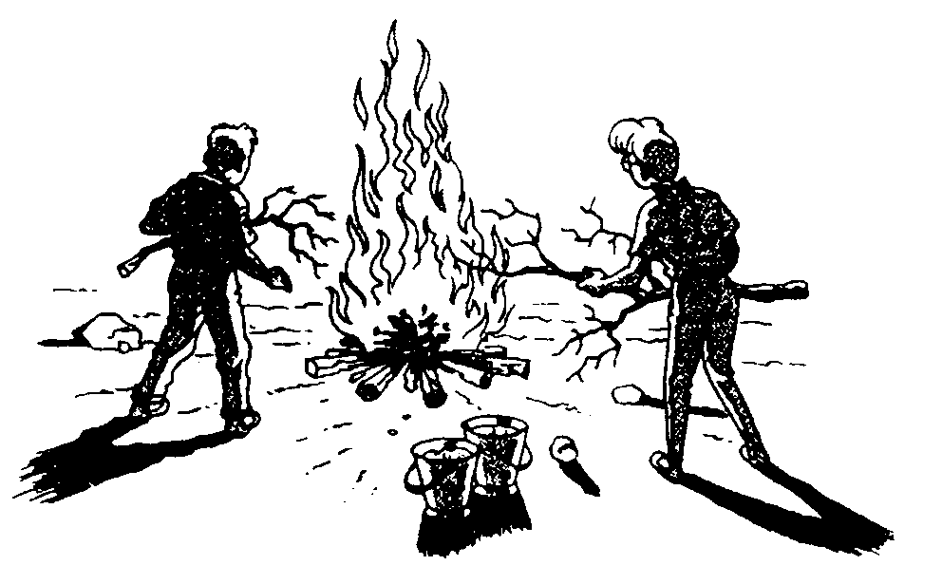
Scouters’ 5
(meeting stories)

#1: Life’s Lessons from Geese
We live in an area where geese are very common. We see them coming in the Fall and leaving early Spring. Their migration is an awesome sight. There is an interdependence in the way geese function.

•FACT: As each bird flaps its wings, it creates an "uplift" for the bird following. By flying in a "V" formation, the whole flock adds 71% greater flying range than if each bird flew alone.
•LESSON: People who share a common direction and sense of community can get where they are going quicker and easier because they are traveling on the thrust of one another.
•FACT: Whenever a goose falls out of formation, it suddenly feels the drag and resistance of trying to fly alone. It quickly gets back into formation to take advantage of the "lifting power" of the bird immediately in front.
•LESSON: If we have as much sense as a goose, we will stay in formation with those who are headed where we want to go.
•FACT: When the lead goose gets tired, it rotates back into the formation and another goose flies at the point position.
•LESSON: It pays to take turns doing the hard tasks and sharing leadership--people, as with geese, are interdependent with each other.
•FACT: The geese in formation honk from behind to encourage those up front to keep up their speed.
•LESSON: We need to make sure our "honking" from behind is encouraging, not something less helpful.
•FACT: When a goose gets sick or wounded or shot down, two geese drop out of formation to follow him [her] down to help and protect him [her]. They stay with him [her] until [s]he is either able to fly again or dies. Then they launch out on their own with another formation or catch up with their flock.
•LESSON: If we have as much sense as the geese, we will stand by each other.

#2: I Wish I Was That Brother

Upon graduation from college, a few years back, a young man received a gift from his older brother. It was a shiny brand new Packard. The car of his dreams! One morning as he approached the car he saw a young lad of 12 peering through the windows into the car! Obviously enthralled with the car, the lad didn't hear the young man approach. "Is this your car?" the lad asked when he noticed the man. "Yes it is!" the man responded! "Wow! This is a nice car!" remarked the lad, "How much did it cost?" "I don't know!" answered the man. "It's your car, but you don't know how much it cost?" exclaimed the young lad. "No," stated the man, "you see, my brother bought it for me!" "I wish...I wish...I wish" stuttered the lad. The man thinking he's going to say, I wish I had a car like this. "I wish I was like that brother!" finished the boy!

Amazed at the lads response he offered to drive him around the block! As they were driving, the lad requested if he would drive him home. Thinking he wanted to show off that he was riding in a new car to his friends, the man agreed! They drove more than a few blocks to where the boy lived and as he turned onto the street the man noticed that it wasn't the best kept neighborhood! The houses were dirty and broken. He pulled up in front of the boys house. "Please wait," the boy yelled as he ran into the house! "Oh, he's probably going to get his family to show off the new car", the man thought to himself.

The door to the front door opened and out came the young lad. In his arms he carried a small boy, crippled from birth! The lad brought him out to the car, and stated as he hugged his younger brother, "See, just like I told you! It's a brand new car! And someday, I'm going to buy you one just like it!"

How unselfish this boy was....to be the kind of brother that looked after other first!

What kind of Scout are you...Are you like the older brother!

#3: One Day At A Time

A friend of ours was walking down a deserted Mexican beach at sunset. As he walked along, he began to see another man in the distance. As he grew nearer, he noticed that the local native kept leaning down, picking something up and throwing it out into the water. Time and again he kept hurling things out into the ocean.

As our friend approached even closer, he noticed that the man was picking up starfish that had been washed up on the beach and, one at a time, he was throwing them back into the water.

Our friend was puzzled. He approached the man and said, "Good evening, friend. I was wondering what you are doing."

"I'm throwing these starfish back into the ocean. You see, it's low tide right now and all of these starfish have been washed up onto the shore. If I don't throw them back into the sea, they'll die up here from lack of oxygen."

"I understand," my friend replied, "but there must be thousands of starfish on this beach. You can't possibly get to all of them. There are simply too many. And don't you realize this is probably happening on hundreds of beaches all up and down this coast. Can't you see that you can't possibly make a difference?"

The local native smiled, bent down and picked up yet another starfish, and as he threw it back into the sea, he replied, "Made a difference to that one!"

•Jack Canfield and Mark V. Hansen taken from "Chicken Soup for the Soul"

#4: " The Left Handshake - The Boy Scout Movement During the War 1939 -45 "
by H St. George Saunders, [ Collins, London 1949] pp139 - 140

No better example of how French Scouts helped their country during the occupation can be found than in the story of Jean Pierre Comboudon, a 16 year-old Rover Scout from Issy les Moulineaux, a suburb of Paris. After the invasion the township was cut off by fighting between allied and occupying troops. Food was not getting through, and there was general disorganisation of services everywhere.

Jean Pierre persuaded the Mayor to give him a free hand. Equipped with two lorries, a small sum in cash and a motorcycle he went around local fields and farms and collected some ten tons of vegetables. Next he ventured further afield into Oise, which was still the scene of actions between the retreating Germans and Canadian forces. He and his companion collected some thirty tons of foodstuffs. On the way back to town he not only had to deal with a flat tyre, but also one of his lorries was hit during an air raid, and he had to put out the resulting fire. On the way he encountered two wounded passers-by, and drove them to the hospital. But the hospital was deserted, empty of staff and supplies. He went around the town collecting medical supplies and bedding and established the wounded in the hospital before continuing his journey back to Issy. Rations for 25,000 people were issued, which fed the inhabitants until the town was liberated by American forces on 26 June after a battle lasting three days. During this time Jean Pierre rescued wounded .

As if this was not enough, he penetrated a position held by 400 desperate SS troops, who were convinced that they would be slaughtered and determined to fight to the last. Jean Pierre managed to persuade them to surrender to the allies, and by so doing saved many lives on both sides.

Ian Ford
Troop 401 BSA
(American School in London)

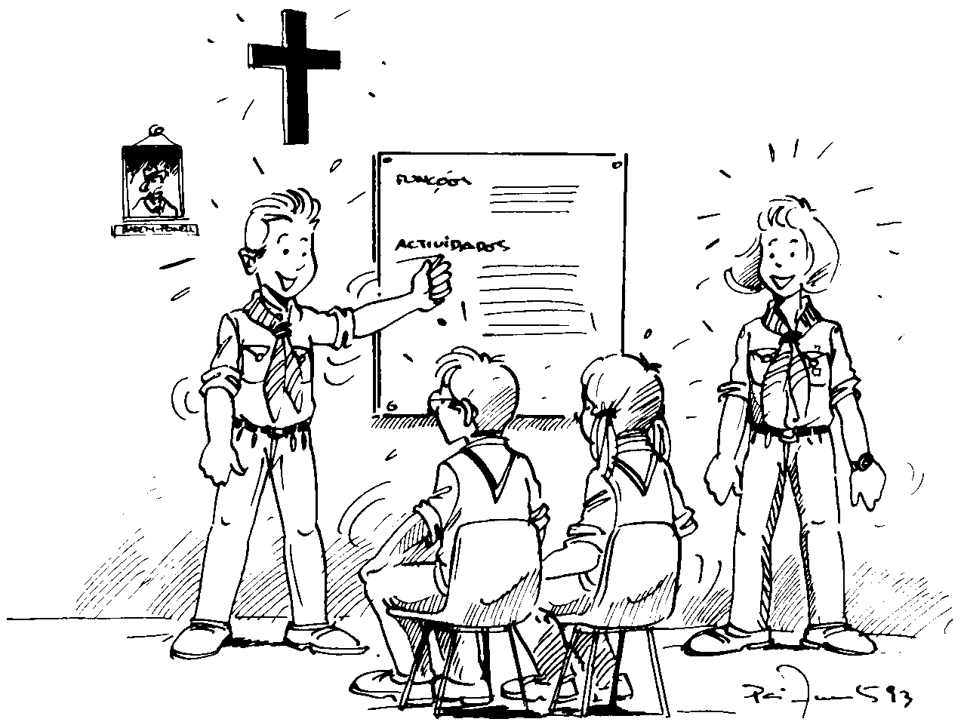

Meeting Prayers

Leadership
O Lord, grant that we may so carry out in our lives the spirit of the Scout Law that we may teach it to others by living it ourselves. Grant also, 0 Lord, that we may understand the true meaning of Service for others, and humbly follow the great example of Our Lord Jesus Christ. Amen.

A Scout is a Friend to All
Fill us, 0 Lord, with Your spirit that we may observe Your command, "Love one another, even as I loved you." May we know the love that sees only the good and is patient and forbearing; that grows stronger when difficulties increase; and that overleaps the barriers of class, of creed, and of country. Help us to love the neighbor we know so that we may learn to love our fellow-men whom we have not seen. Strengthen the bond between Scout and Scout in our Group, in our land, and throughout the World. So may we further the coming of Your Kingdom of goodwill and love; following the example of Jesus Christ. Amen

For Our Country
Almighty God, our Heavenly Father, bless our Country that it may be a blessing to the world. Grant that our ideals and aspirations may be in accordance with Your will, and help us to see ourselves as others see us. Keep us from hypocrisy in feeling or action. Grant us sound government and just laws, good education and clean lives, justice in our relations with one another, and, above all a spirit of service which well abolish pride of place and inequality of opportunity; through Jesus Christ our Lord. Amen.

A Closing Prayer
May the blessing of Almighty God rest upon us and upon all our work; may He give us Light to guide us, Courage to support us, and Love to unite us, now and evermore. Amen.

The Final Thought to Take Home
" Hold on to the good things in life that you have accomplished, For they are a reminder of the goodness within you."
--- Author Unknown ---

" Help your brother to climb the hill
And you will find yourself nearer the top."
--- Author Unknown ---

" Life consists not in holding good cards,
But in playing those you hold well."
--- Albert Einstien

" Happiness lives for those who cry, those who hurt, those who have searched, and those who have tried. For only they can appreciate the importance of people who have touched their lives."
--- Author Unknown ---

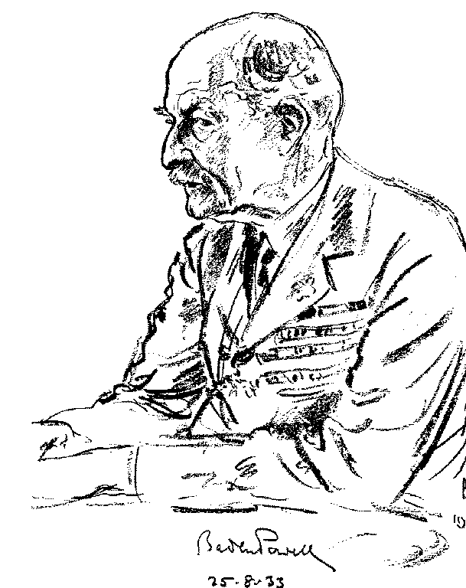
Please send your
ideas and hints to

SCOUTING@canada.com

